# NPRE 201

**Homework #3**

\**Show all work and calculations to receive full credit*

1. Fill in the Blank:

Oil trapped in shale or sand is more expensive than oil that has accumulated in reservoirs, which is when porous material naturally accumulates over organic material.

1. Fill in the Blank:

In a stage called catagenesis or cracking oil is formed and cracked. At a temperature of around 450C, this cracked oil turns into crude oil; while at a temperature of around 200C, the cracked oil turns into natural gas.

1. Below is an Integrated Gasification Combined Cycle (IGCC). Why is this cycle considered to be more environmentally friendly than traditional coal fired plants?

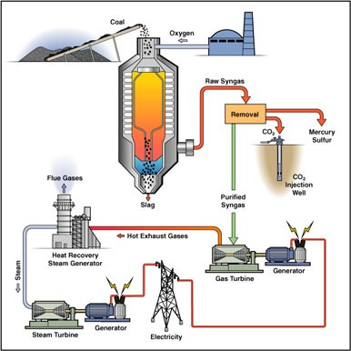

This is more environmentally friendly than traditional coal because it takes the CO2 and instead of emitting it, it traps it underground.

1. Explain what developments over the past 20 years were made to make Advanced Coal more competitive.

Coal plants have implemented pulverization to extract as much energy as possible out of coal, they have also been incorporated into integrated gasification combined cycles and pressurized fluidized bed combustion.

1. Explain how primary, secondary, and tertiary extraction recovery oil work.

Primary

* Uses pressure of the oil to extract oil and this nets ~30 of the total oil in the reserve

Secondary

* Uses pressure from injected liquids to extract oil and this nets 30%-50% of oil in the reserve

Tertiary

* Uses pressure from gas or chemical injections to extract up to 80% of the oil in the reserve

1. Below is a pie chart showing the percentages of oil the three different extraction methods recover. Write the name of the method and percentage next to the area on the chart it represents.

Secondary: 10%

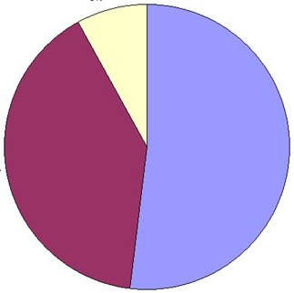

Tertiary: 55%

Primary: 35%

1. T/F: Shale in North America is primarily found along the West Coast of the United States.
   1. True b) False
2. Fill in the blank: Shale is a type of rock.
   1. Igneous
   2. Metamorphic
   3. Sedimentary
   4. Limestone
3. What are the product gases of a typical gasification chamber? (HINT: there are 4 of them.)

CnH(2n+2)

H2O

Oxygenates

H­2

1. Fill in the blank:

Heat-driven turbines convert only a small percentage of thermal energy into

mechanical.

1. Below is a diagram of a co-generation cycle. Some of the names of the components have been removed and replaced with letters. Write the name of the component each letter has replaced with.

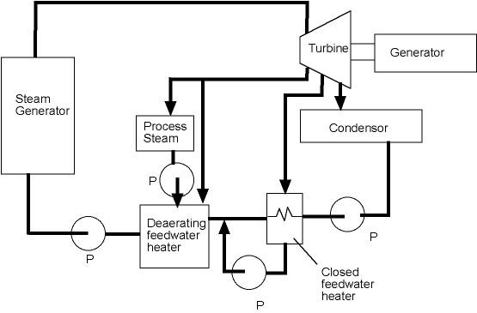

B

A

D

C

A is generator B is turbine

C is condenser D is combustion chamber

1. Fill in the blank: Sulfur dioxide reacts with atmospheric oxygen to produce

SO­3. This reacts with rainwater to produce H2SO4, or acid rain.

1. What was the largest source of sulfur dioxide emissions in North America in from 1950s on?

a) Petroleum refining b) Ceramic product manufacturing

c) Chemical manufacturing d) Electricity production <- though coal burning

1. Why is acid rain a primarily regional rather than local or global problem?

The sulphur emitted goes into the atmosphere and into the clouds, which forms sulphuric acid. However, this is local because the increased particulate matter in the atmosphere allows the water in the clouds to condense easier, which means that they do not travel as far, and the acid rain stays close to the source.

1. What planet is an example of a runaway greenhouse? How has this occurred?

Venus had this runaway greenhouse effect because whenever CO2 was emitted, it warmed the atmosphere and this warming caused the water, which is a potent greenhouse gas, on the surface to evaporate, which caused the temperature to rise, which caused more water to evaporate, and so on. There is also no carbon cycle on Venus that helps regulate the amount of carbon in the atmosphere.

1. By about how many percent did atmospheric carbon dioxide increase between the years of 1960 and 2020?

Roughly 30% from 315 ppm to 415 ppm

1. From heaviest to lightest, what are the distillates that come out of a crude oil distillation?

Gasses, including methane, ethane, propane, and butane

Naphtha, which is used to make plastics

Gasoline, which is used to power cars

Kerosene, which is jet fuel

Diesel, which is used to power heavy vehicles

Gas Oil, which is primarily used in residential heating

Residual Fuel oil, which is used for large ships and some heating applications

1. Give one example of a cogeneration power plant and explain what the waste heat is used for in that particular scenario.

An example of a cogeneration plant would be the microreactor that will be installed on campus as it will have the capacity to generate steam for heat and electrical power.

1. Which region of the United States has the biggest problems with acid rain and sulfur emissions? What might be a possible explanation for this?

Easy coast as they are closest to Appalachia, which has an abundance of coal, the primary reason for acid rain.

1. Describe the advantages of developing hydrogen as a fuel and the advantages of using hydrogen fuel cells for electricity production

The advantages of hydrogen as fuel are that it can be produced with renewable energy when the renewable energies are working at their maximum (i.e., day for solar and winter for wind) and allow the use of those energies into the periods of time where they are not able to produce power. Hydrogen fuel cells also do not produce any negative emissions, only water.